How To Add Spystream app Script in Wordpress Site ?

- In plugin section click on Add new and you will find the search plugin option.
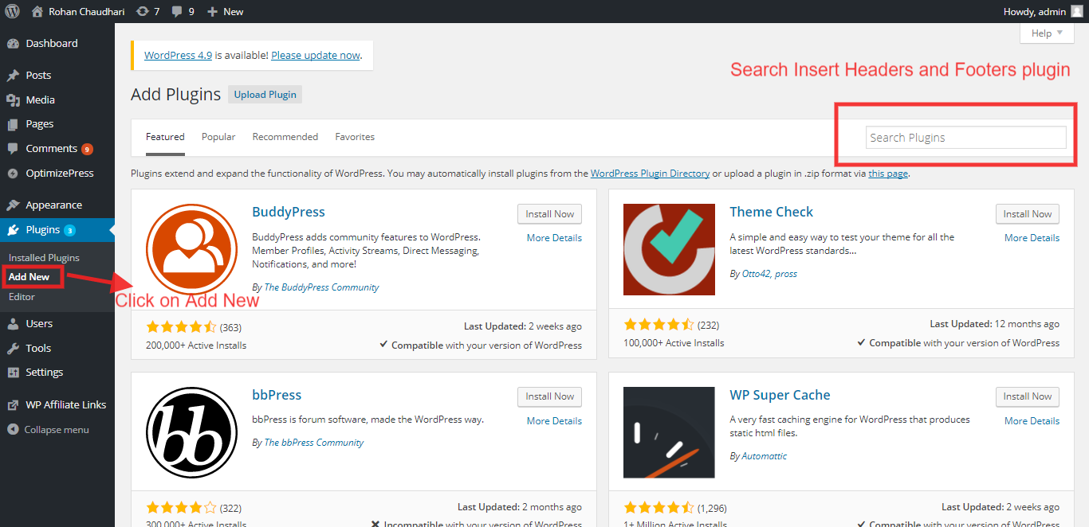

2)Search Insert Header and Footer plugin in search box
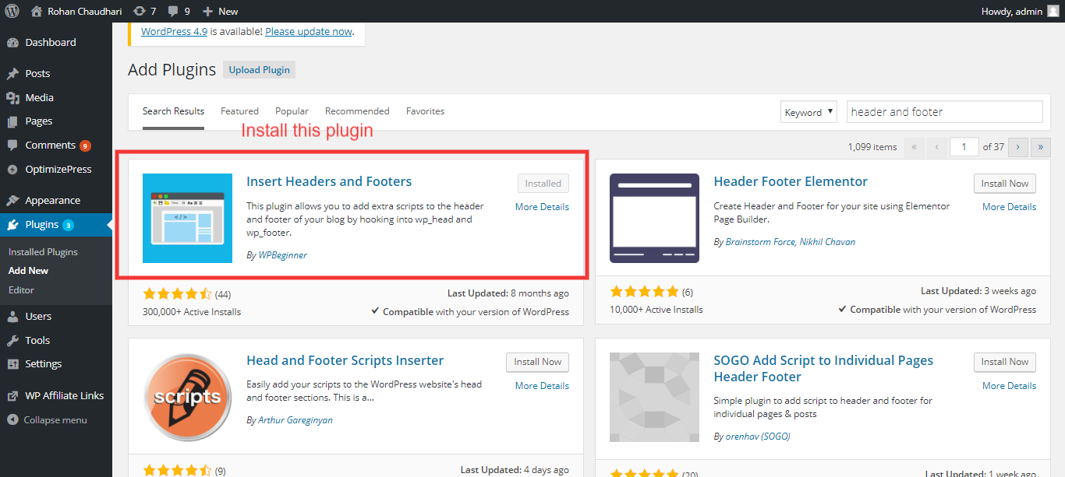

3)After installation of Insert header and footer plugin,you will find the plugin under setting section.
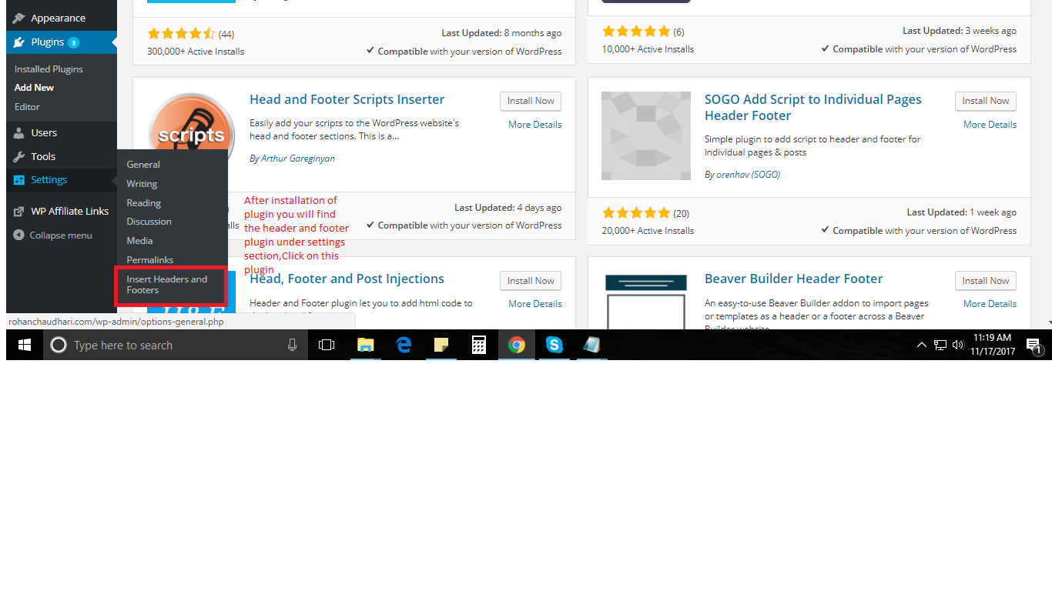
4) In that plugin add Spystream app script in header section and you are good to go.
