- Login to user Cpanel
- Find your header file like [heder.php / header.tpl] where you have to add Spystream Script.

For example :
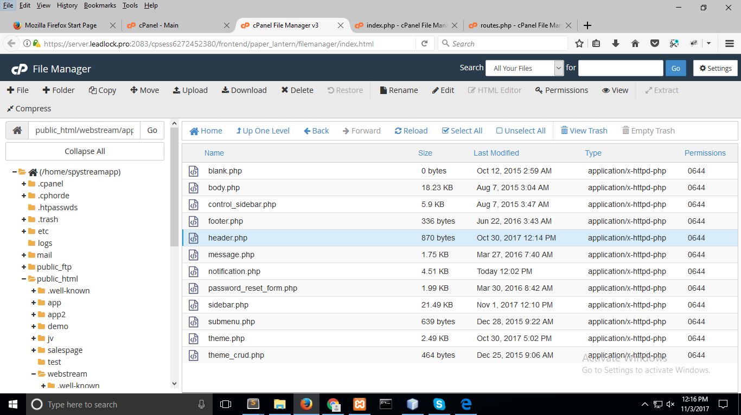

3. Place your Spystream tracking code in your head tag.

Example: <head> // paste code here </head>
